**EXPERIMENT NO 1**

**AIM: To prepare the front/home page of your website.**

<!DOCTYPE html>

<html>

<head>

<title> Bleed For Cause </title>

<link rel="shortcut icon" href="plz.ico" />

</head>

<body>

<img src="bb.png" width="50" height="70" style="margin-left:10px">

<h1 style="color:red; font-family:Courier; display:inline-block; ">blood</h1>

<h1 style="color:black; font-family:Courier; display:inline-block; ">Connection</h1>

<img src="sec.png" width="300" height="80" style="margin-right:20px; float:right; margin-top:20px">

<pre style="font-size:200%"> HOME ABOUT US ABOUT BLOOD REQUEST VOLUNTEER CONTACT US</pre>

<img src="imp.jpg" width="1250" height="700" style="margin-left:10px">

</body>

</html>

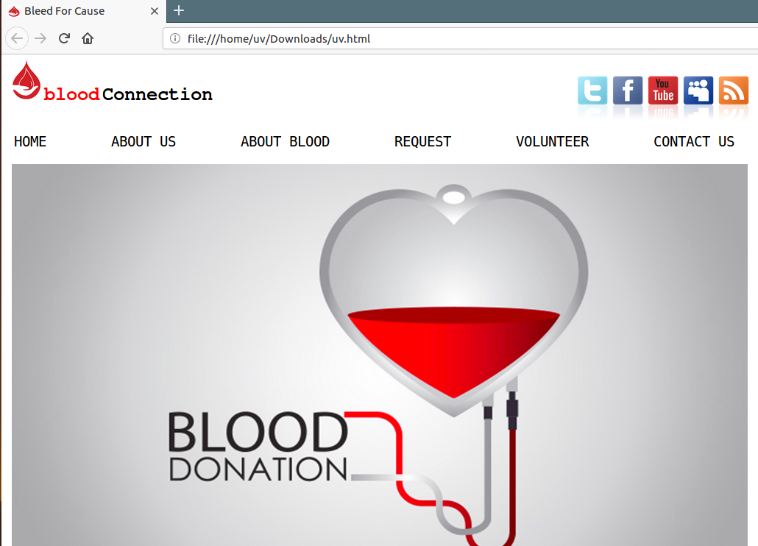

**EXPERIMENT NO 2**

**AIM: To include a table in your html file.**

<!DOCTYPE html>

<html>

<head>

<title> Bleed For Cause </title>

<link rel="shortcut icon" href="plz.ico" />

<style>

table, th, td {

border: 1px solid black;

border-collapse: collapse;

}

th, td {

padding: 5px;

text-align: left;

}

</style>

</head>

<body>

<img src="bb.png" width="50" height="70" style="margin-left:10px">

<h1 style="color:red; font-family:Courier; display:inline-block; ">blood</h1>

<h1 style="color:black; font-family:Courier; display:inline-block; ">Connection</h1>

<img src="sec.png" width="300" height="80" style="margin-right:20px; float:right; margin-top:20px">

<pre style="font-size:200%"> HOME ABOUT US ABOUT BLOOD REQUEST VOLUNTEER CONTACT US</pre>

<table style="width:100%">

<caption style="font-size:200%">Donate Now</caption>

<tr style="font-size:150%; margin-top:50px">

<th>BLOOD BANK</th>

<th>ADDRESS</th>

<th>PHONE NUMBER</th>

</tr>

<tr>

<td>Lions Blood Bank</td>

<td> Ak-100, Shalimar Bagh, Delhi - 110088 </td>

<td>011-47125887</td>

</tr>

<tr>

<td>Indian Red Cross Society</td>

<td> 1, Red Cross Road, Parliament Street, Delhi - 110001</td>

<td>011-47189966</td>

</tr>

<tr>

<td>Rotary Noida Blood Bank</td>

<td>E-2, IMA Bhawan, Nithari Road, Noida Sector 31, Noida - 201303</td>

<td>011-26418899</td>

</tr>

<tr>

<td>Pitampura Blood Bank</td>

<td> Building Number B 294, 0, Pitampura, Delhi - 110034</td>

<td>011-26477889</td>

</tr>

<tr>

<td>Venkateshwar Hospital</td>

<td>Phase-2, Sec - 18, Dwarka, Delhi - 110075</td>

<td>011-55778899</td>

</tr>

</table>

</body>

</html>

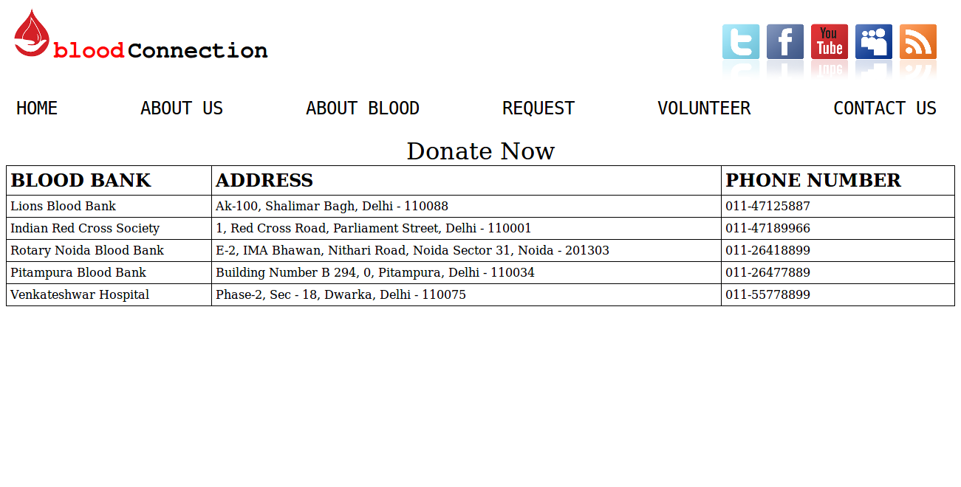

**EXPERIMENT NO 3**

**AIM: To show the use of <form> tag in your html file.**

<!DOCTYPE html>

<html>

<head>

<title> Bleed For Cause </title>

<link rel="shortcut icon" href="plz.ico" />

</head>

<body>

<img src="bb.png" width="50" height="70" style="margin-left:10px">

<h1 style="color:red; font-family:Courier; display:inline-block; ">blood</h1>

<h1 style="color:black; font-family:Courier; display:inline-block; ">Connection</h1>

<img src="sec.png" width="300" height="80" style="margin-right:20px; float:right; margin-top:20px">

<pre style="font-size:200%"> HOME ABOUT US ABOUT BLOOD REQUEST VOLUNTEER CONTACT US</pre>

<img src="ii.png" width="200" height="200" style="margin-left:370px">

<form action="/action_page.php" target="_blank" method="POST" style="margin-top: 100px; display:inline-block;">

USERNAME<br>

<input type="text" name="firstname" value="Mickey" style="margin-top:10px">

<br> <br>

PASSWORD<br>

<input type="password" name="Password" value="pswd" style="margin-top:10px">

<br><br>

<input type="submit" value="Submit" style="margin-top:10px">

</form>

</body>

</html>

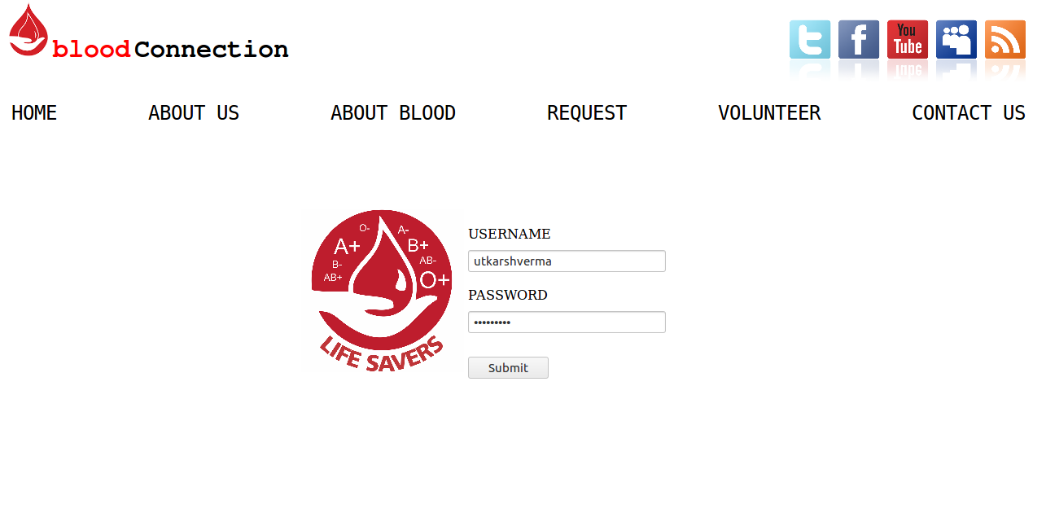

**EXPERIMENT NO 4**

**AIM: To install Xampp server on the system.**

**PROCEDURE:**

1. First we have to download the Xampp server package from official website i.e. apachefriends.org. Download link is [*https://www.apachefriends.org/download.html*](https://www.apachefriends.org/download.html)*.*

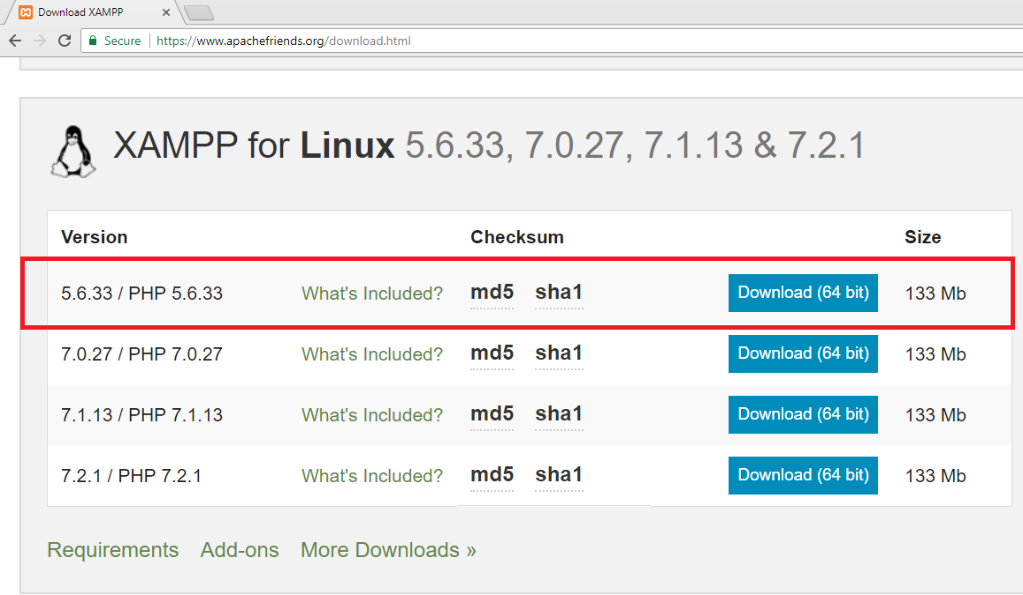

1. After downloading the Xampp package server(most probably in the Downloads folder of the system), change the directory to the Downloads folder which contain the executable file of the software.



1. Switch to super user.



1. But we cannot install this package without execute permission, hence to give permission we use the below command.



1. Use the below command to start the installation of Xampp server.



1. So after the execution of the above command we will get the below screen in front of you. Here just click **Next** to start the installation.

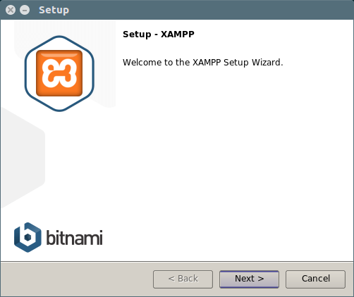

1. Now we select the components we want to include in installation and click on **NEXT.**

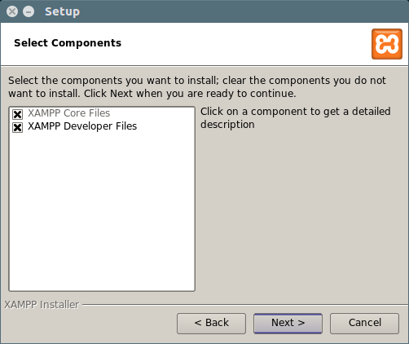

1. Click on NEXT to continue the Xampp server Installation.

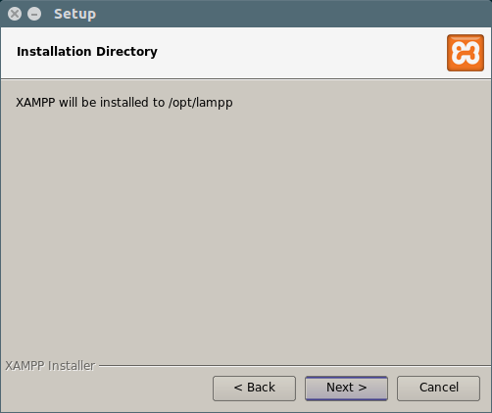

1. Click on **NEXT.**

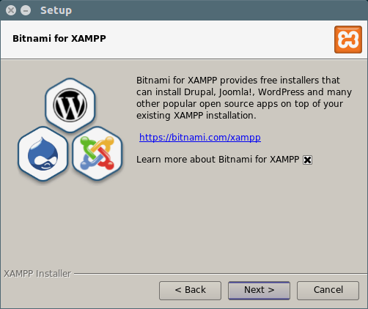

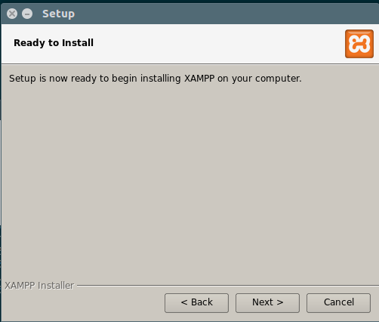

1. Installation is in progress.

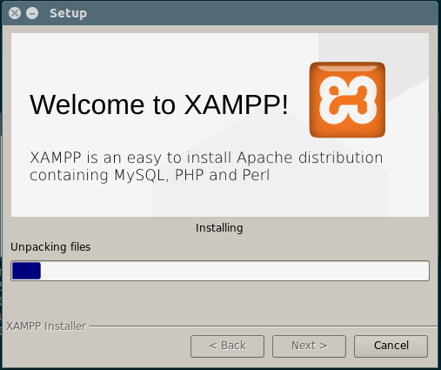

1. Click on the **finish** to complete the installation process and Xampp Server will automatically open. This completes the installation process.

